**ME 361 LAB REPORT**

|  |  |  |
| --- | --- | --- |
| Experiment number | : | 5 |
|  |  |  |
| Sub-Group number | : | A4 |
|  |  |  |
| Name | : | Avinash Kumar |
|  |  |  |
| Roll number | : | 150169 |
|  |  |  |
| Date & Day experiment was conducted on | : | 9th October, 2017 Monday |
|  |  |  |
| Date of submission of report | : | 16th October, 2017 Monday |

**OBJECTIVE:**

To fabricate a three-dimensional object using the fused deposition additive manufacturing process (part A), and to its measure dimensions using a coordinate measuring machine (part B).

**REPORT:**

***Part A*:**

1. 3D printing and CNC is totally contrast in almost all aspects:
2. 3D printing is nothing but additive manufacturing where material is added layer by layer to get final object but CNC machine is conventional manufacturing where material is removed to get final object. So, simply 3D printing is addition and CNC is substraction method.
3. As 3D printing is addition of material, no wastage of material will be there while in CNC wastage is considerable.
4. In 3D printing G & M codes are generated automatically (when you slice the 3D object in slicing software) but in CNC we need to enter whole G & M codes manually. So 3d printing saves your lot of time.
5. Z layer separation, also called delamination, is the phenomena of having one or more layers in the Z axis not sticking correctly to the layer beneath it. This is often more visible near the corners and edges of the printed piece. This issue is normally not related to the printer itself, but rather to the user-defined settings and elements. 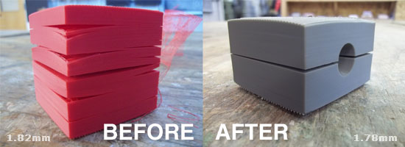

Reasons for delamination defects:

**Low temperature:** it is possible that the temperature is high enough to be extruded out of the nozzle but not high enough for the extruded filament to correctly stick to the previous layer.

**High speed:** printers are becoming increasingly fast and precise, but the mechanical and chemical properties of the polymers do have some limitations. Sometimes it is better to err on the side of caution and go for a slower printing speed to ensure that the extruded filament has enough time to properly connect with the previous layer

**Type of filament being used:** as mentioned before, ABS is the most troublesome material to work with when it comes to delamintation.

1. Support materials do the job of holding the base metal in place. They are mainly important in complex geometry where we have a lot of hanging parts. Support materials are removed after the job is completed.

***Part B*:**

The reasons for deviation are:

1. The major reason for deviation of the measured profile from the design profile if the lesser number of data points especially near the curved reasons due to which curved profiles cannot be extrapolated properly.
2. Another reason for deviation is the deflection of the probe tip when it touches the sample thus inducing errors in experimental profile.
3. Due to uneven surface of the base of experimental part, it was not parallel to the base of the machine leading to in coincidence of the X-Z plane of experimental part and machine thus, giving erroneous profiles.